CLARA’S BEST: WEB-BASED ORDERING AND RESERVATION SYSTEM

Prepared By:
Janine M. Batle

Course & Subject:
IT312L – System Integration and Architecture 2

Instructor:
Jeremiah C. Dela Cruz

Date Submitted:
5/21/2026

- Introduction
Background of the System
The Clara’s Best: Kakanin Delicacies, situated in the municipality of Poblacion, Hinunangan, Southern Leyte, serves as a local culinary business that provides customers with a variety of traditional Filipino kakanin products and delicacies. For several years, the business has managed its day-to-day operations through a traditional, manual record-keeping framework—a labor-intensive methodology that relies heavily on handwritten order slips, notebooks, social media conversations, and paper-based transaction records to document critical business information. These manual entries are used to track daily sales transactions and cash flow, monitor inventory levels of ingredients and kakanin products, record customer order details and payment confirmations, as well as maintain sales summaries and operational records. While this manual system was sufficient during the early stages of the business operation, the continuous increase in customer demand and transaction volume has exposed several administrative inefficiencies and operational bottlenecks. Physical records remain highly vulnerable to accidental loss, damage, and misplacement; furthermore, the absence of a centralized digital system creates significant risks to data accuracy and business continuity, as a single incident of record loss could permanently remove valuable financial, customer, and inventory information essential to the daily operations of the business.

Purpose of the System
The primary objective of this project is to design, develop, and implement a tailored web-based ordering and reservation system for Clara’s Best: Kakanin Delicacies using Laravel 12. By transitioning from manual paper-based procedures to a centralized digital platform, the system establishes an organized and efficient environment that seamlessly connects administrators, staff members, and customers. Specifically, the proposed platform automates the core business processes by integrating online ordering, real-time inventory monitoring, payment verification, sales reporting, and customer account management into a single web application. Additionally, the system provides role-based dashboards that allow authorized users to efficiently manage transactions, monitor order progress, and maintain accurate operational records. Ultimately, the purpose of the project is to eliminate administrative inefficiencies, improve transaction accuracy, reduce data redundancy, and ensure that all business information is securely stored, easily searchable, and readily accessible.

Importance of the Project
Modernizing this food business is crucial because manual record-keeping directly compromises the operational efficiency, transaction accuracy, and financial security of the establishment. In a kakanin business environment, inventory tracking errors can lead to unexpected shortages of ingredients and menu items, while miscommunicated customer order details may result in delayed preparation and incorrect transactions—both of which negatively affect customer satisfaction and daily operations. Implementing this web-based platform minimizes human calculation errors, prevents data loss caused by damaged or misplaced records, and significantly reduces the time spent manually preparing sales reports and monitoring inventory levels. Furthermore, this digital transformation provides Clara’s Best with the operational efficiency and data accuracy necessary to scale its services, maintain organized customer transaction histories, and deliver a more reliable and convenient ordering experience to customers within the municipality of Hinunangan.

Problems the System Aims to Solve
  - Vulnerability to Data Loss: Vulnerability to Data Loss: Reliance on handwritten order slips, notebooks, and paper-based transaction records that lack digital redundancy, making essential customer, financial, and inventory data highly susceptible to accidental loss, damage, and misplacement.
  - Inaccurate Inventory Tracking: Frequent manual stock monitoring errors that result in unexpected shortages of ingredients and kakanin products or unnecessary overstocking of supplies.
  - Order Processing and Communication Bottlenecks: Delayed order confirmations and miscommunicated customer requests caused by the absence of a centralized digital ordering and monitoring system between staff and customers.
  - Inefficient Financial Reporting: A labor-intensive and error-prone reporting process that requires extensive manual computation and cross-checking to generate sales summaries and transaction records.
  - Operational Inefficiencies: Administrative delays and workflow disruptions caused by traditional manual processes that limit the business’s ability to efficiently manage increasing customer demand and transaction volume.

- Objectives of the System
General Objective
To design and develop CLARA’S BEST: WEB-BASED ORDERING AND RESERVATION SYSTEM that digitalizes the business operations of Clara’s Best through an efficient and centralized web-based platform.
Specific Objectives
- To provide customers with an online ordering and reservation system for kakanin products.
- To implement real-time inventory monitoring for products and ingredients.
- To automate payment recording, order tracking, and reservation management.
- To provide a secure Point of Sale (POS) system for physical walk-in sales.

- Scope and Limitations
Scope
The proposed platform is engineered around a comprehensive, multi-tier user authentication system that provides distinct, secure dashboards for Administrators, Staff, and Customers to ensure seamless transaction management and operational control. At its core, the system streamlines food ordering and reservation processing through a centralized digital platform designed to handle customer orders, reservation schedules, payment monitoring, and real-time transaction recording. To ensure operational continuity, the application manages inventory tracking by continuously monitoring kakanin products, ingredients, and menu availability while automatically triggering visual dashboard notifications whenever stock levels fall below a specified minimum threshold. Furthermore, the platform automates financial reporting by compiling transaction data into filtered daily, weekly, and monthly sales summaries, allowing administrators to monitor revenue trends and business performance efficiently. Finally, the scope includes a digital payment configuration panel where administrators can upload a static GCash QR code, enabling customers to conveniently submit proof of payment during the checkout and reservation process for manual staff verification.

Limitation
To establish clear project boundaries and define the operational constraints of the application, several technical areas are explicitly excluded from this phase of development. First, the platform is entirely web-based and relies on a continuous internet connection to synchronize real-time order transactions, reservation schedules, and inventory updates, meaning it does not support an offline operational mode. Additionally, the system functions purely as a digital ordering and reservation management platform and does not integrate with external food delivery services, automated kitchen equipment, or Point of Sale hardware devices such as receipt printers and barcode scanners. Lastly, the current scope does not support native SMS gateway services or automated online payment API integration, restricting all reservation confirmations, payment verification, and order notifications exclusively to the web application interface with manual staff validation.

- System Description
The system follows a modern Model-View-Controller (MVC) architecture. It is divided into three major modules tailored for specific user roles:
Admin Portal
Full control over users, menu items, inventory records, sales reports, and system settings.
Staff Hub
Focused on operational tasks including order processing, payment verification, inventory monitoring, and order status updates.
Customer Portal
User-friendly interface for browsing kakanin products, placing orders, uploading payment proofs, and viewing order history.

- Technologies Used
- Laravel 12
- Backend Framework
- MySQL 8.0
- Database System
- Tailwind CSS
- Styling Engine
- Alpine.js
- Frontend Interactivity

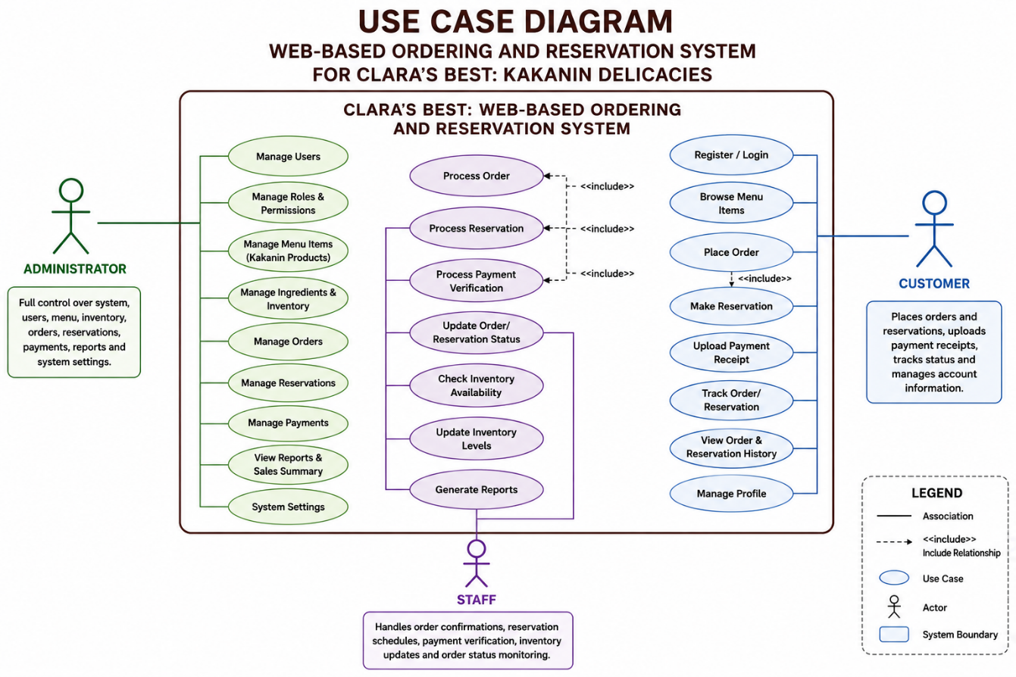
- System Design
Figure 1: Use case Diagram

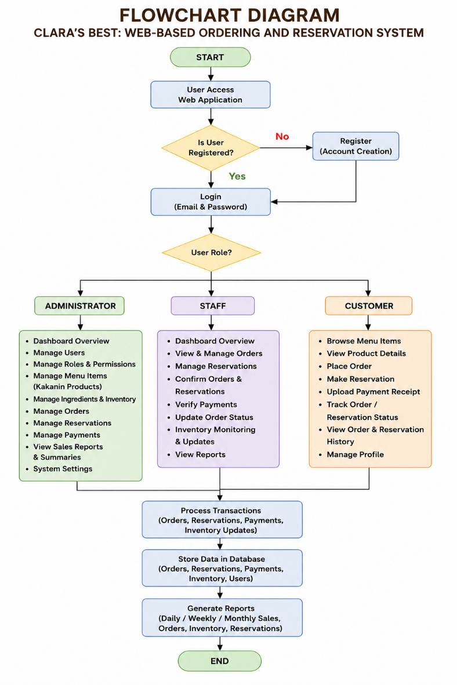
This use case diagram illustrates the functional requirements of the Web-Based Ordering and Inventory Management System for Clara’s Best: Kakanin Delicacies, detailing how three distinct actors interact within the system boundary. On the left, the Administrator possesses full control over the application, interacting with administrative functions such as managing users, menu items, inventory, orders, reports, and system settings. On the right, the Customer handles external user activities including registration, login, browsing products, placing orders, uploading payment receipts, tracking orders, and managing account information. At the bottom, the Staff actor bridges operational processes by handling order confirmations, payment verification, inventory updates, and order status monitoring. Additionally, the diagram highlights the internal relationships between ordering, payment processing, and inventory monitoring functions that collectively support the complete business workflow.

Figure 2: Flowchart Diagram

This flowchart diagram outlines the operational workflow and user routing of the web application system based on user roles and permissions. The process begins when a user accesses the application, leading to a decision point that checks whether the user is registered. Unregistered users are directed to create an account, while registered users proceed directly to the login page using their credentials. Once authenticated, the system evaluates the user’s assigned role—Administrator, Staff, or Customer—and redirects them to their respective dashboard modules. Administrators manage inventory, users, menu items, reports, and system settings; Staff members process orders, verify payments, and update order statuses; while Customers browse products, place orders, upload payment proofs, and track transactions. All operational processes eventually connect to the centralized database where transaction records are stored and reports are generated before the workflow concludes.
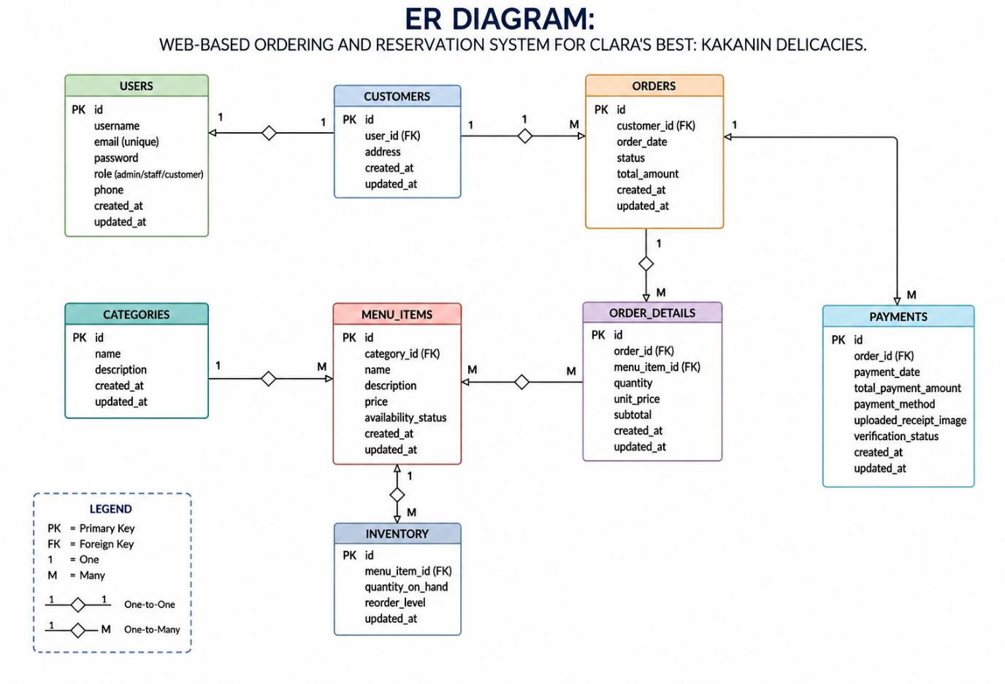

Figure 3: Er Diagram

This Entity-Relationship (ER) diagram represents the database structure for the web-based ordering and reservation system, demonstrating how the major data tables interact through specified relationships. At the core of the database structure is the USERS table, which stores customer, staff, and administrator account information. Customers can create multiple ORDERS, while each order is connected to detailed transaction records in the ORDER_DETAILS table. Payment information and uploaded receipt images are stored within the PAYMENTS table, which is linked directly to the corresponding orders. Additionally, the MENU_ITEMS table manages product information such as descriptions, prices, and availability, while the CATEGORIES table organizes menu classifications. Inventory monitoring is supported by dedicated inventory records that continuously track product quantities and stock availability.

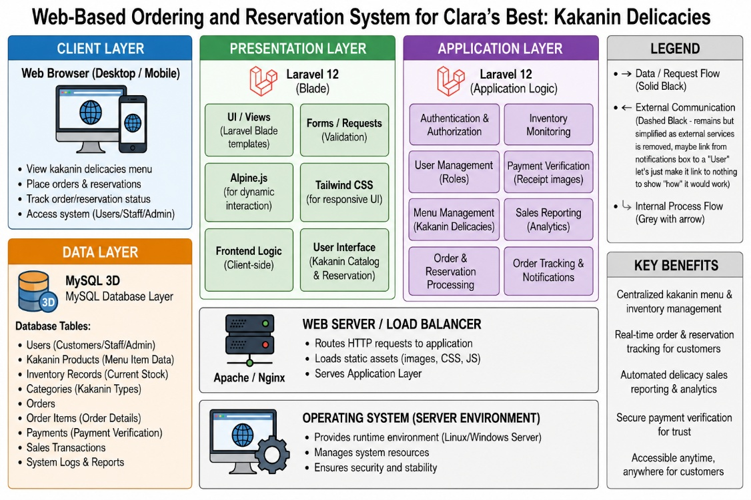
Figure 4: System Architecture Diagram
This system architecture diagram illustrates the multi-layered technological framework powering the web-based ordering and inventory management system for Clara’s Best: Kakanin Delicacies. At the front end, customers, staff members, and administrators interact with the Client Layer through desktop or mobile web browsers. These requests are forwarded to the Presentation Layer, which utilizes Laravel Blade templates, Tailwind CSS, and Alpine.js to handle responsive user interfaces and dynamic frontend interactions. The Presentation Layer communicates with the core Application Layer powered by Laravel 12, where the primary business logic—including authentication, order processing, inventory monitoring, payment verification, and sales reporting—is executed. Beneath the application layer, the system operates through an Apache or Nginx Web Server that routes incoming HTTP requests. Finally, all transaction records and operational data are stored within the MySQL Database Layer, ensuring organized and secure data management for the entire platform.

Interface design/Screenshot
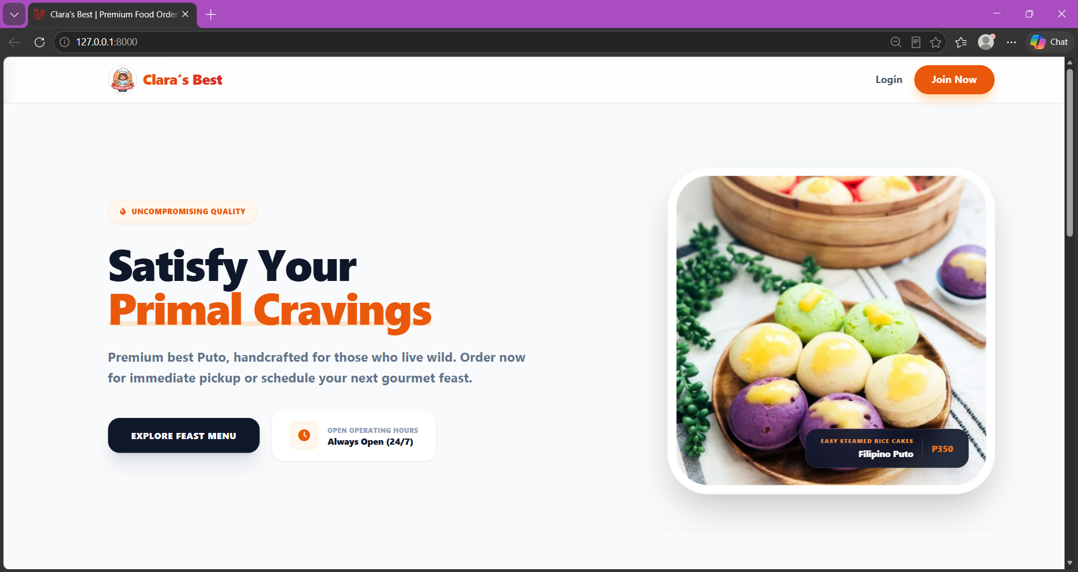
Figure 5: Home Page
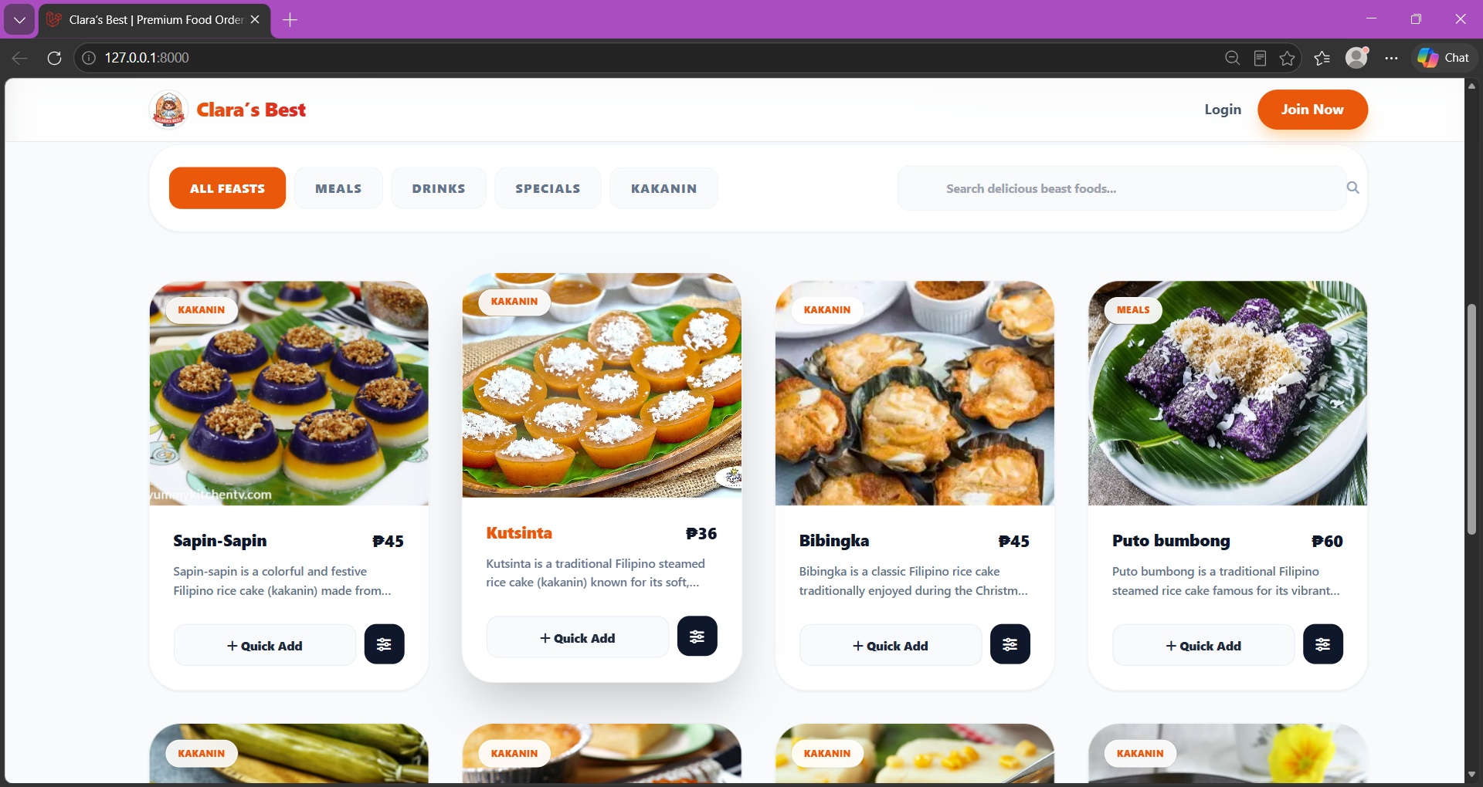
Figure 6: Menu
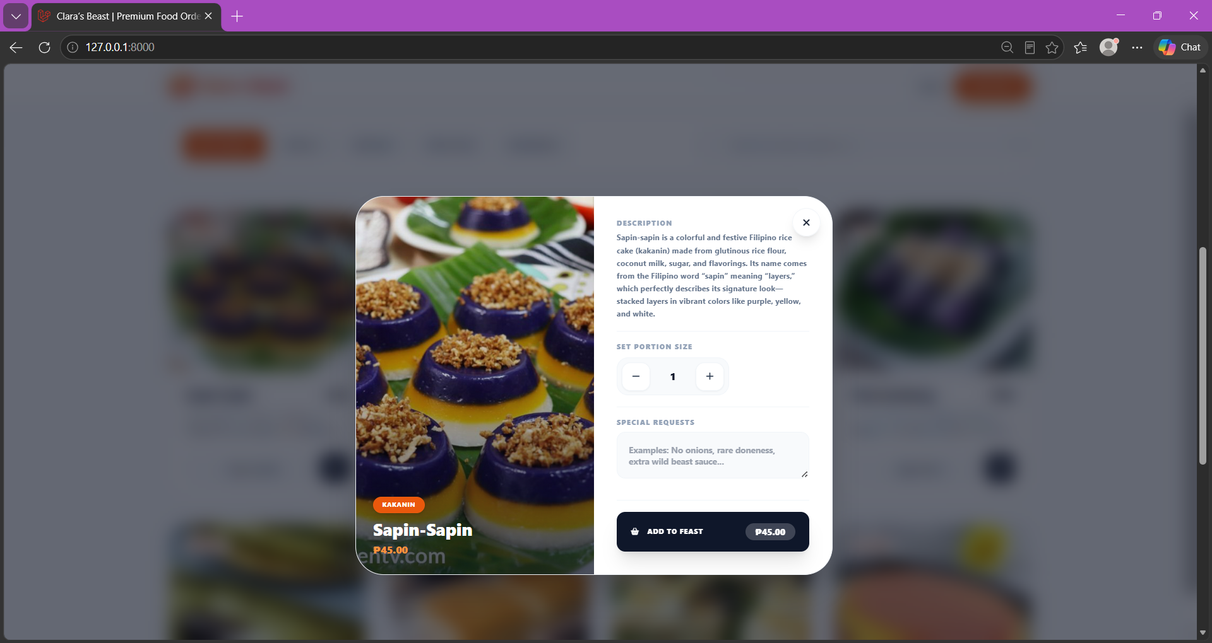
Figure 6: Menu Details
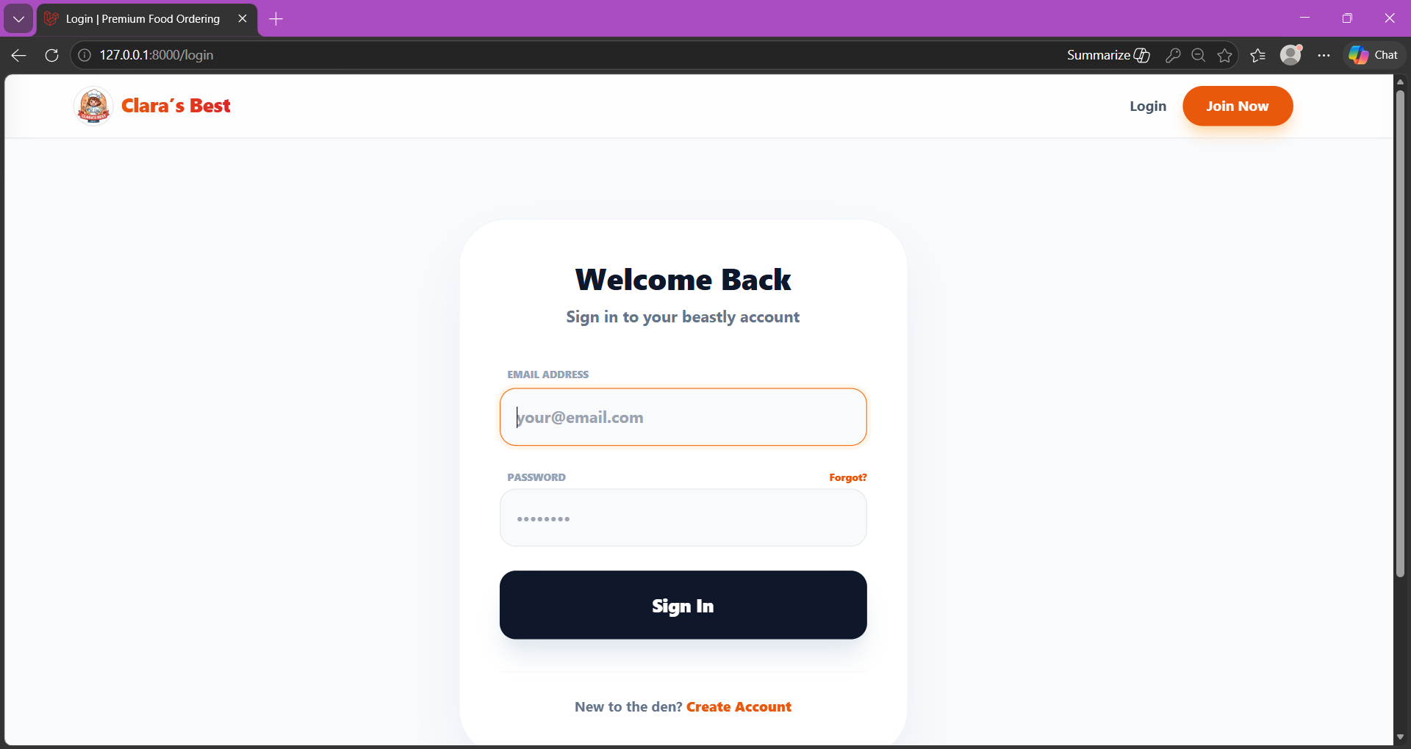
Figure 7: Login Page
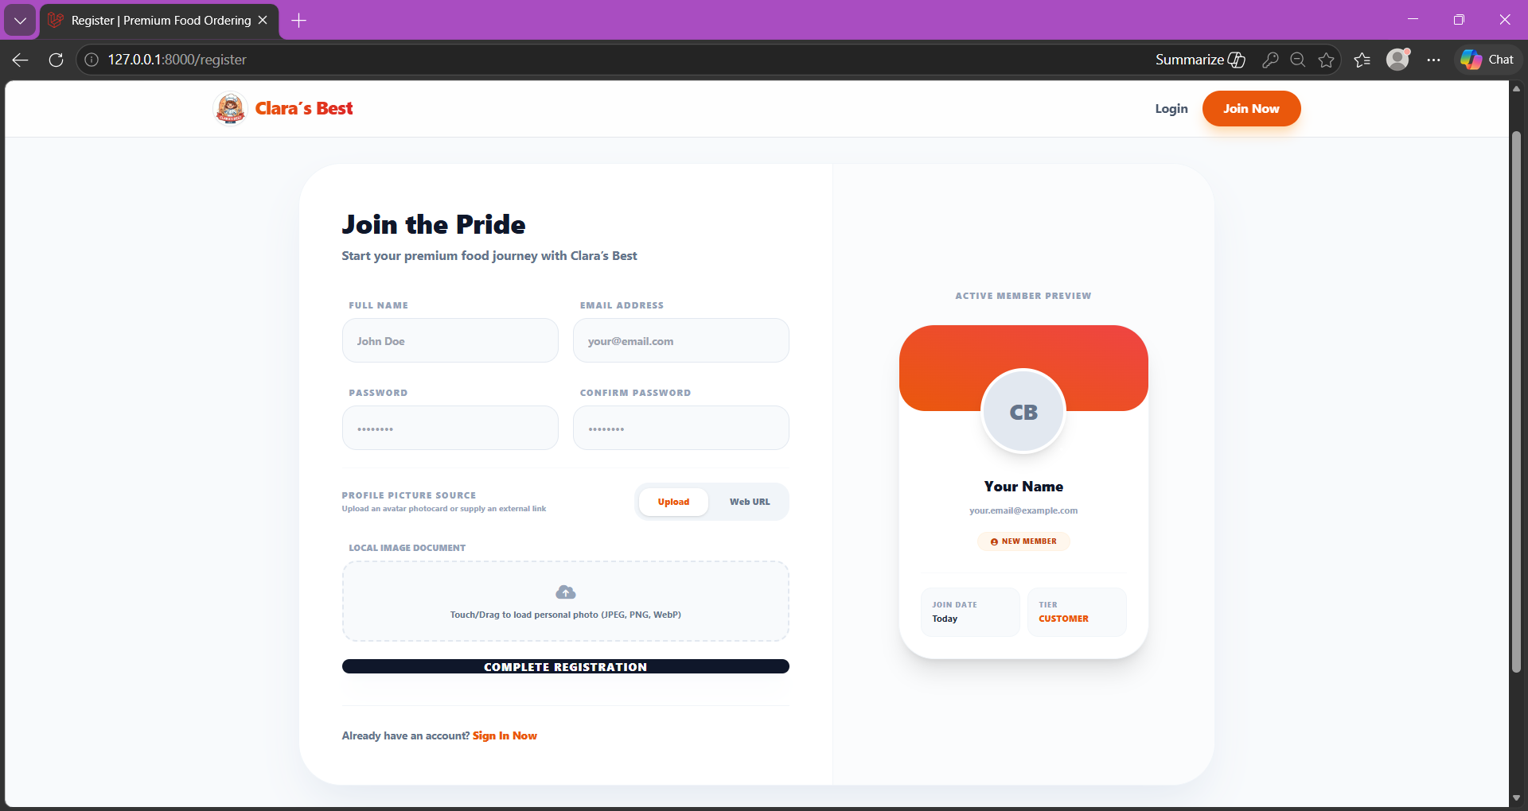
Figure 8: Register Page
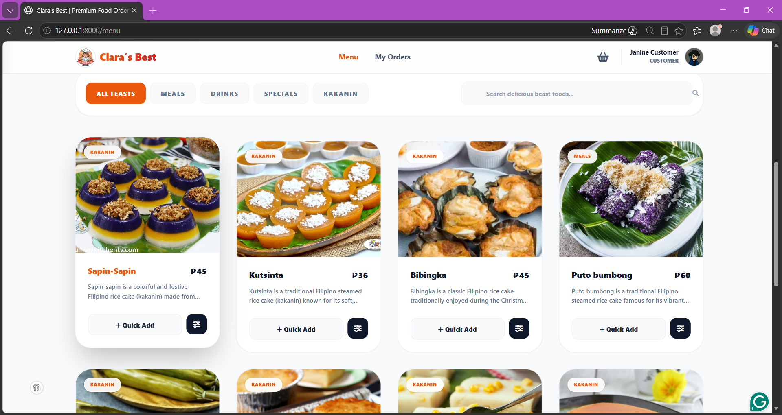
Figure 9: Customer Menu
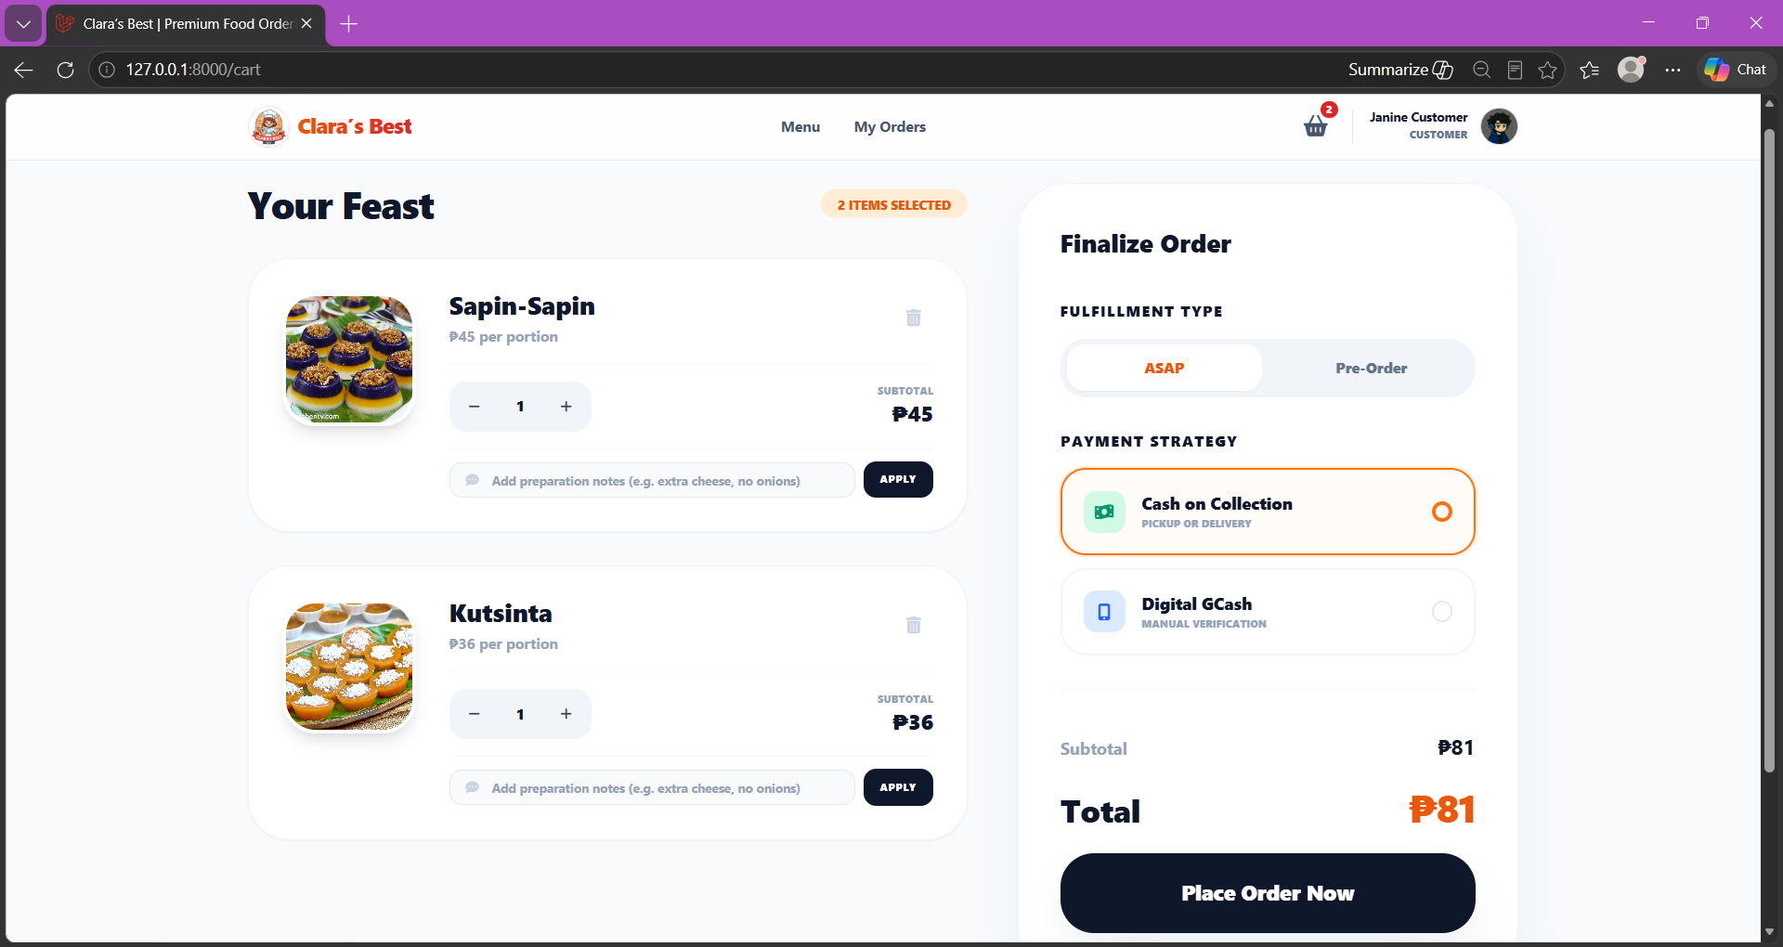
Figure 10: Customer Cart
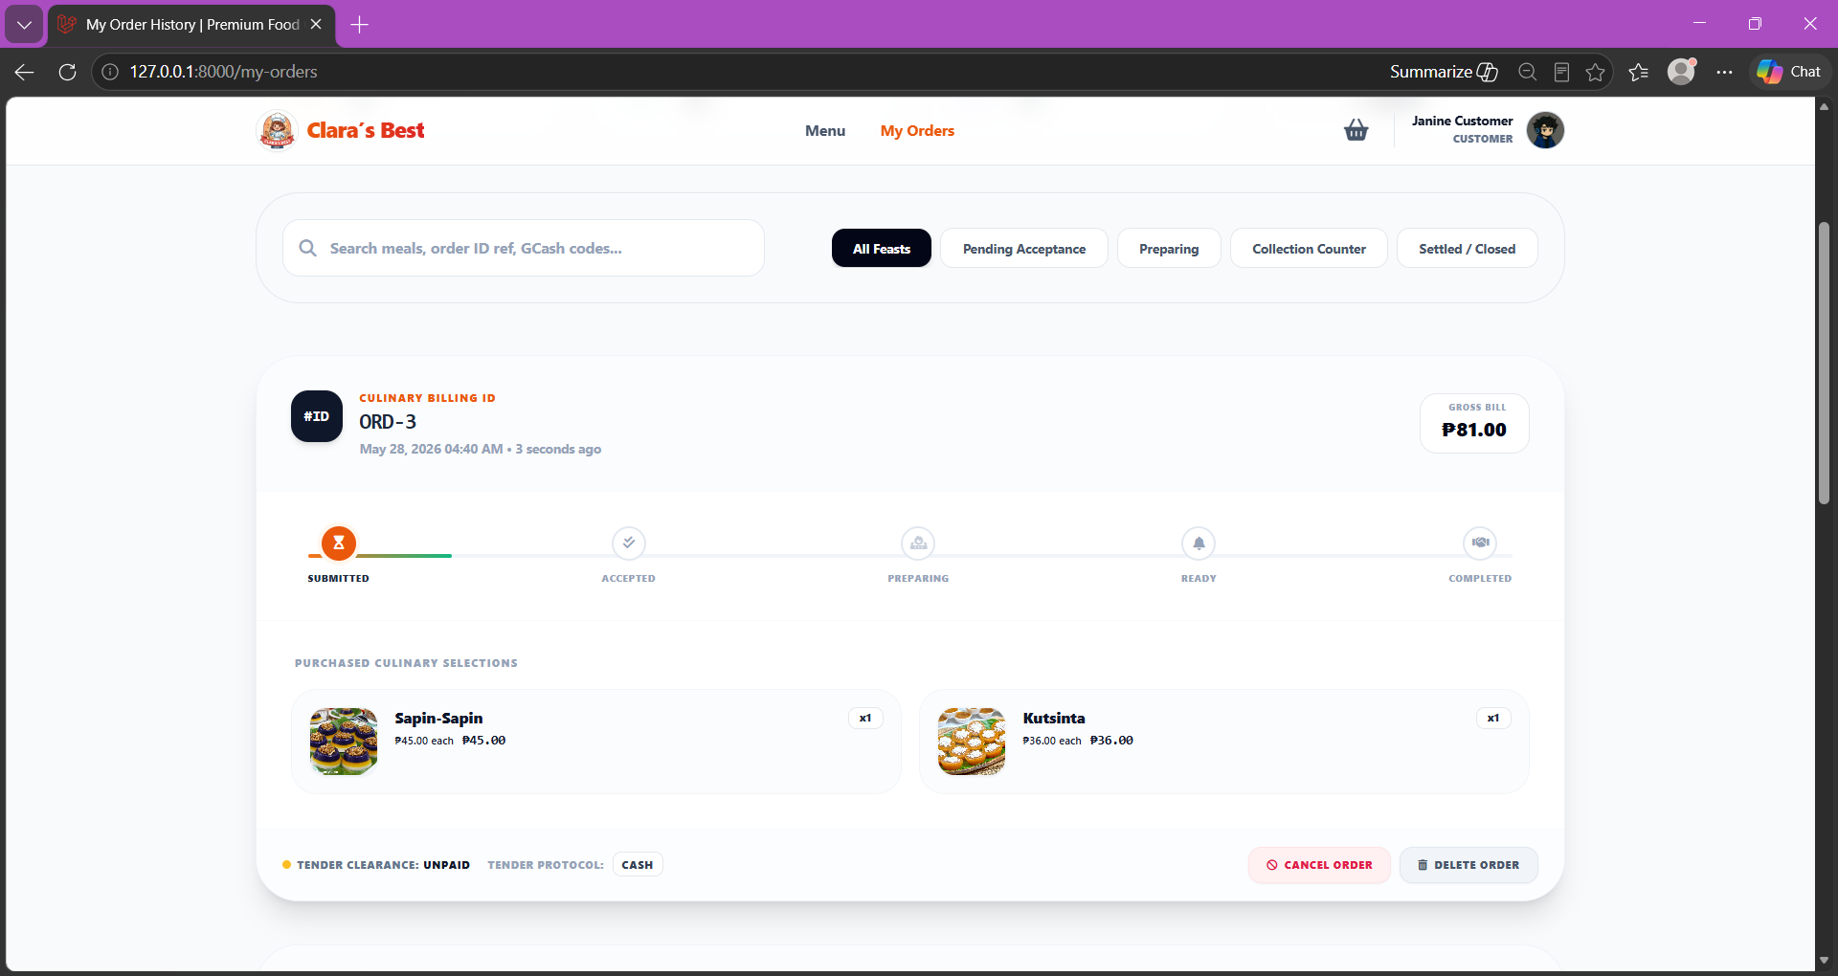
Figure 11: Customer Orders
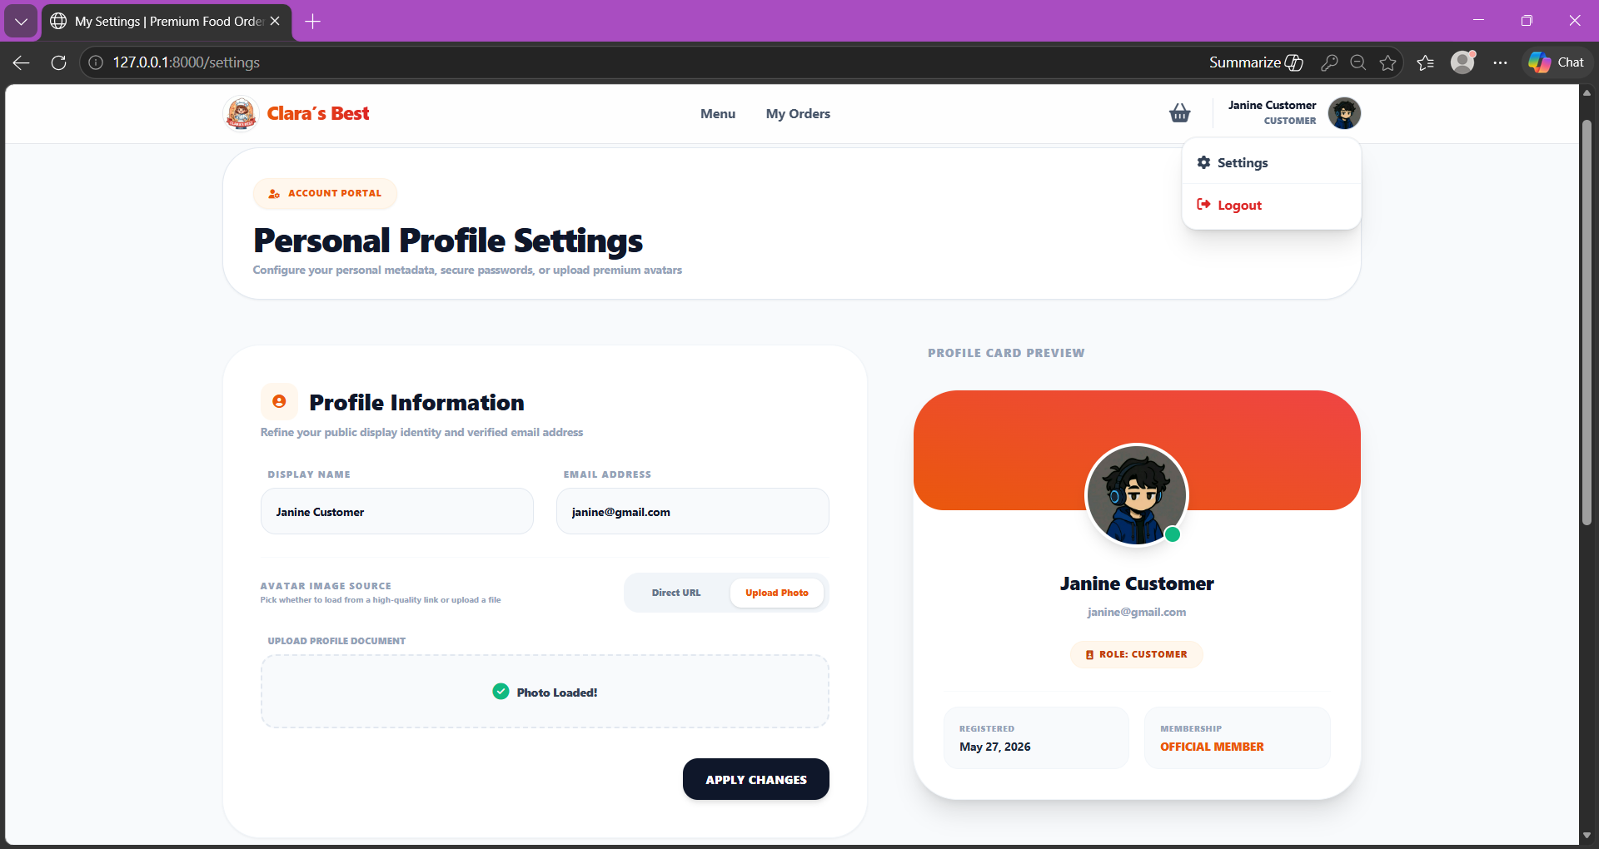
Figure 12: Customer Settings
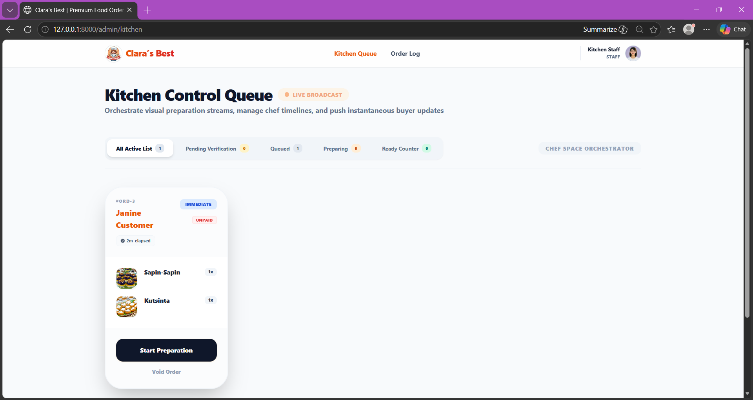
Figure 13: Staff Kitchen Queue
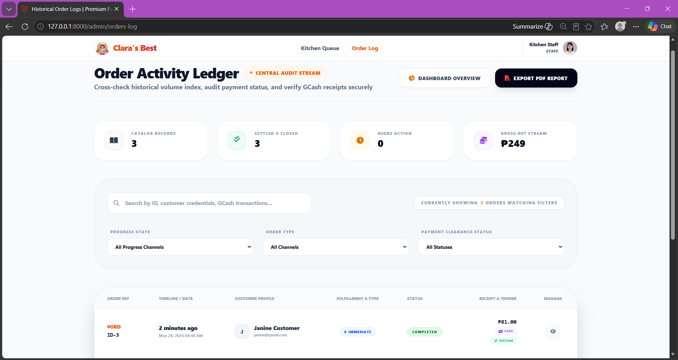
Figure 13: Staff Order Log
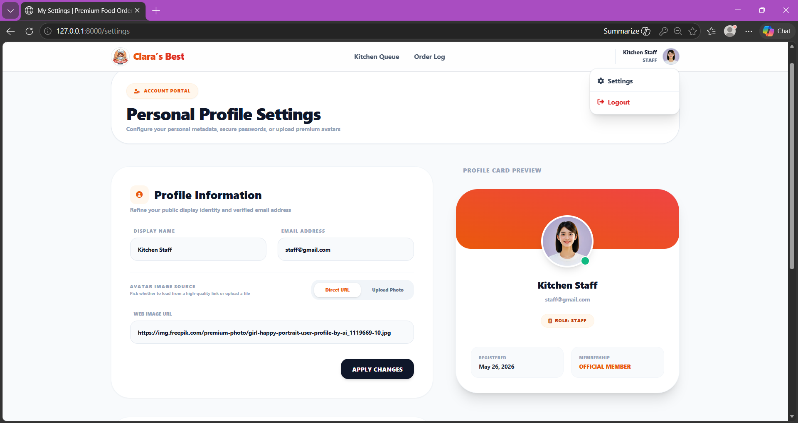
Figure 13: Staff Settings
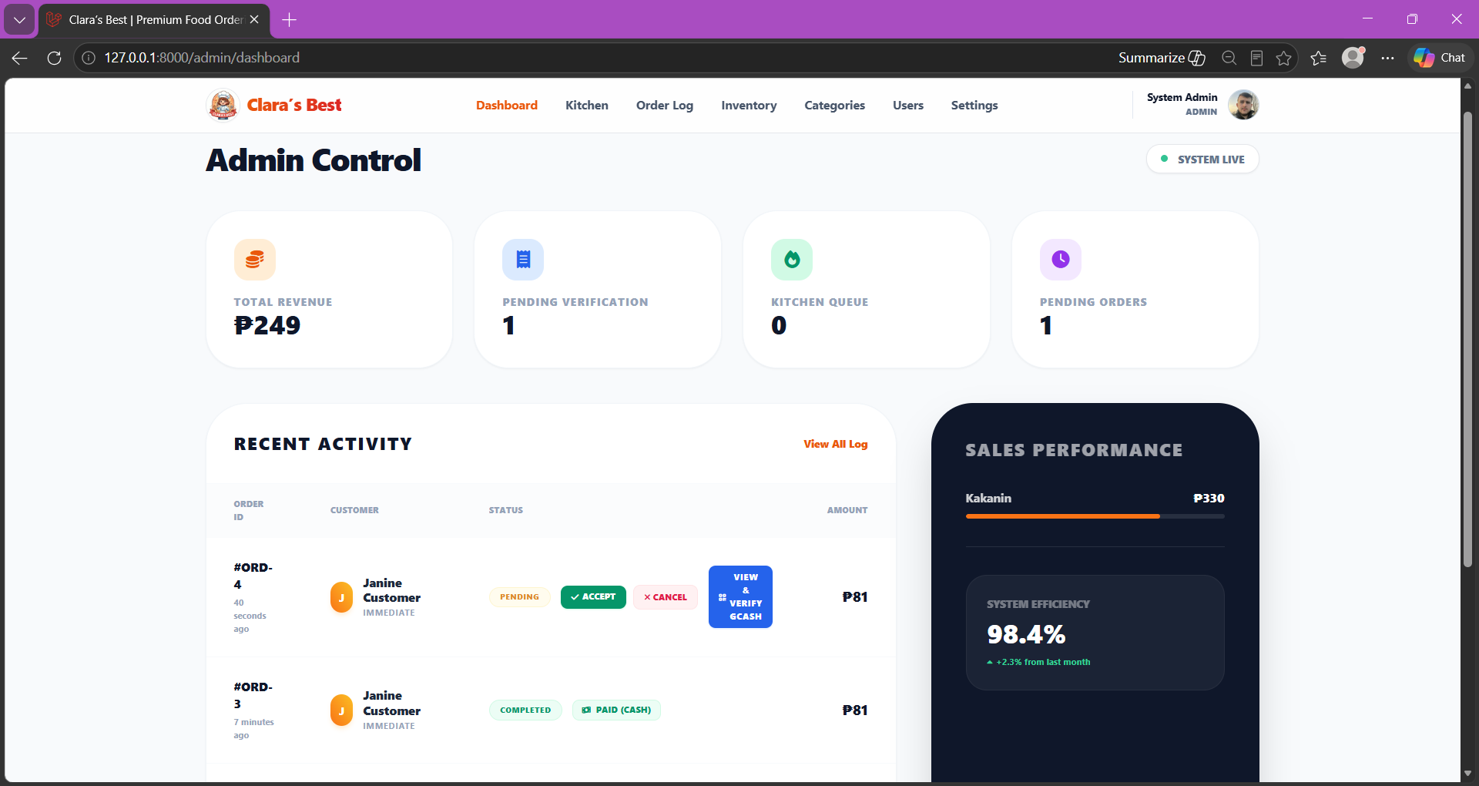
Figure 14: Admin Dashboard
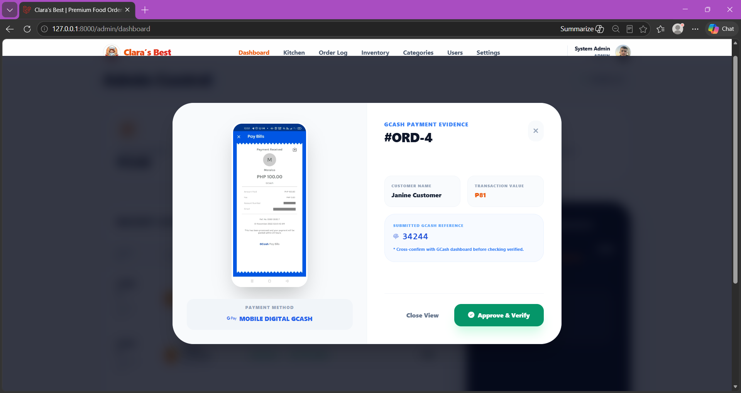
Figure 15: Admin View GCash Payment Evidence
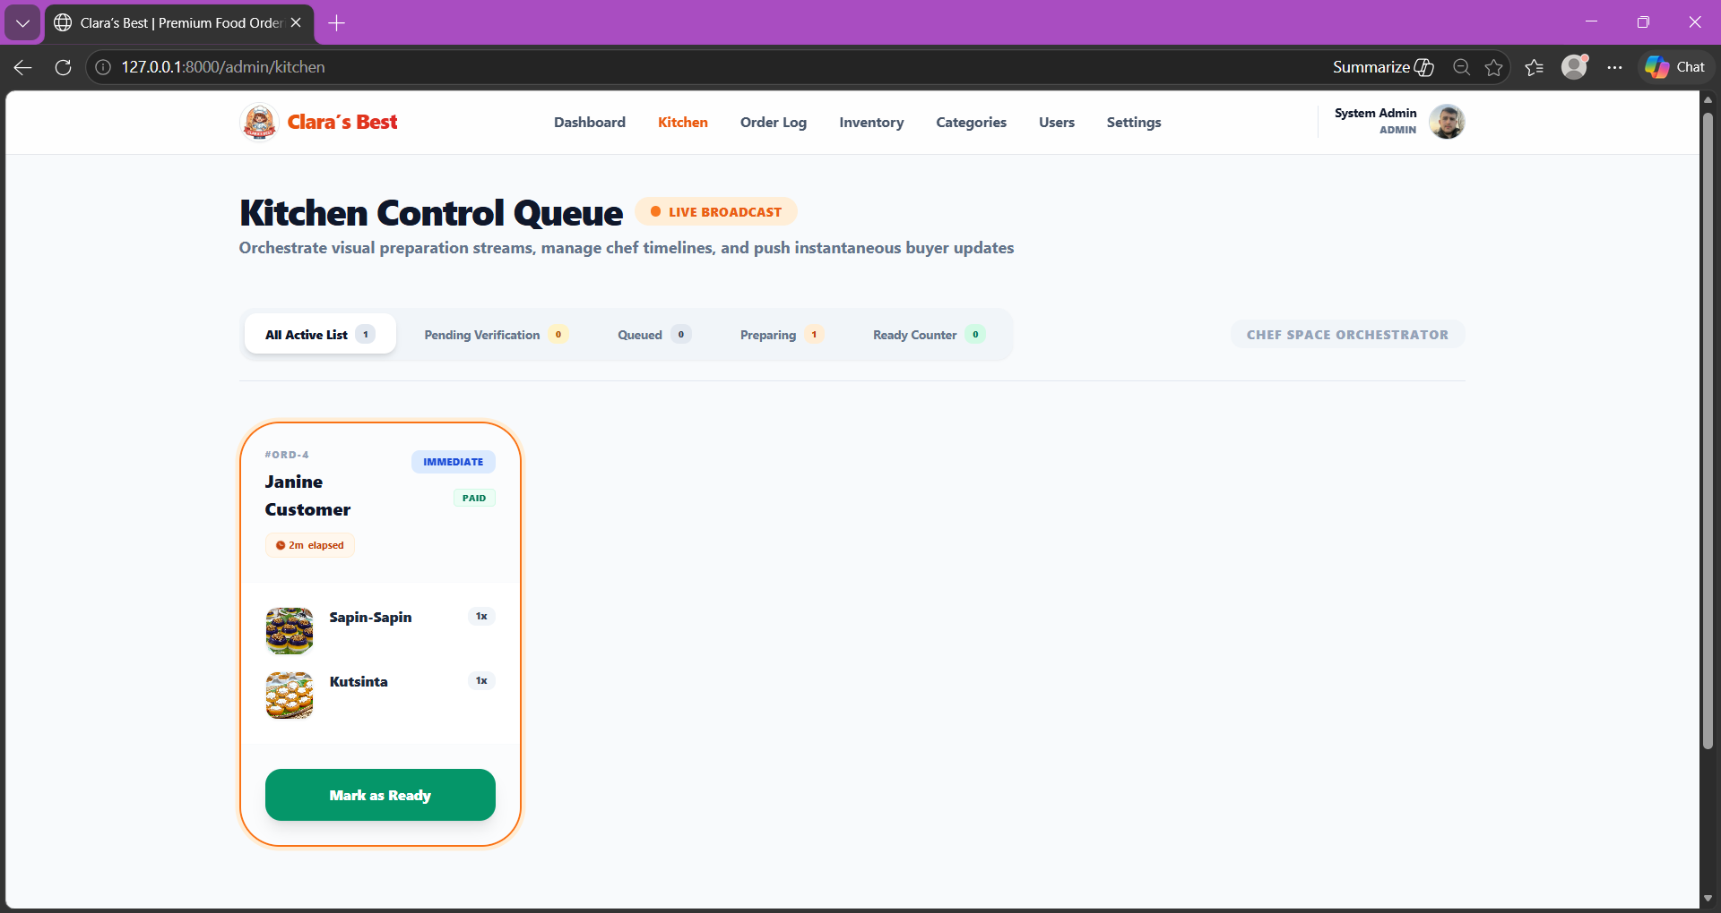
Figure 16: Admin Kitchen
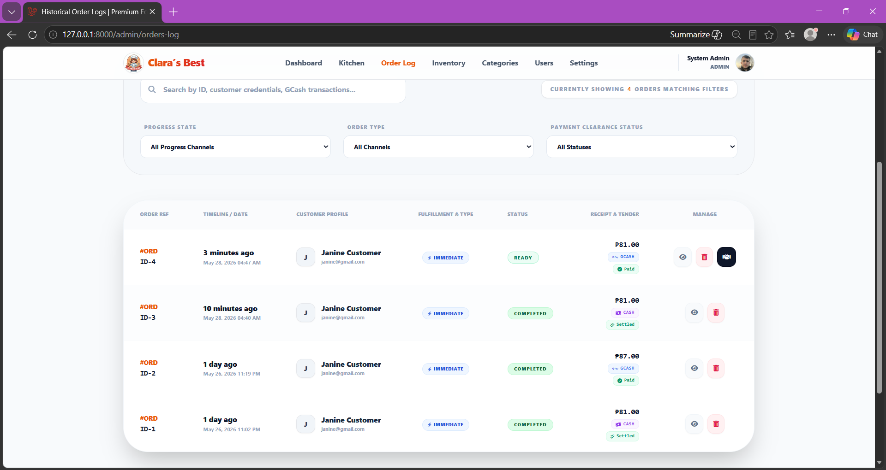
Figure 17: Admin Order Log
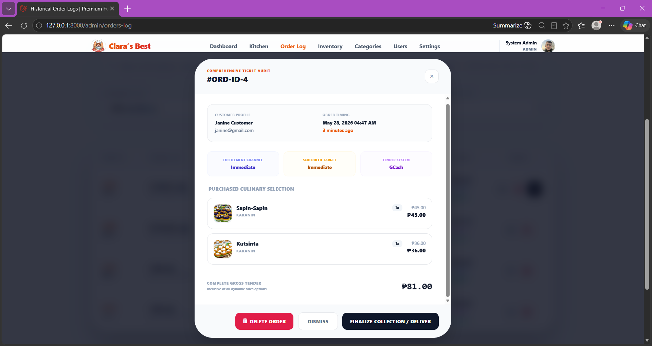
Figure 18: Admin View Order
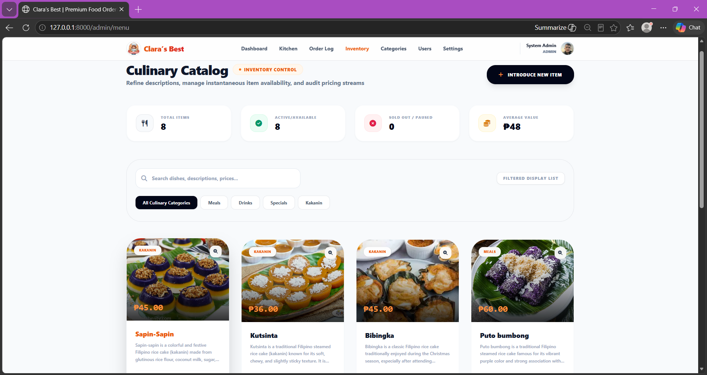
Figure 19: Admin Inventory
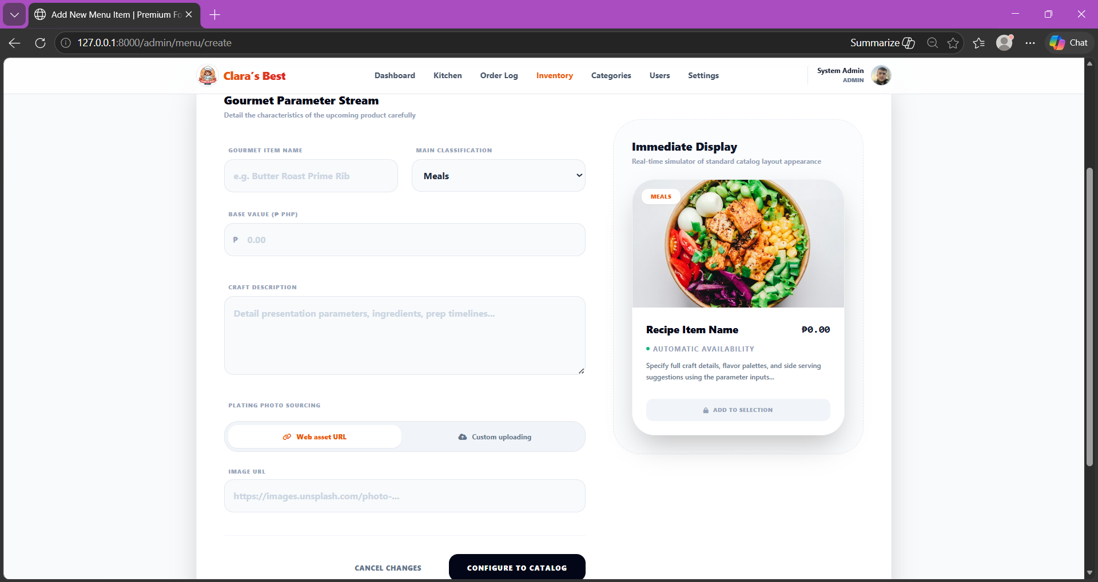
Figure 20: Admin Add menu
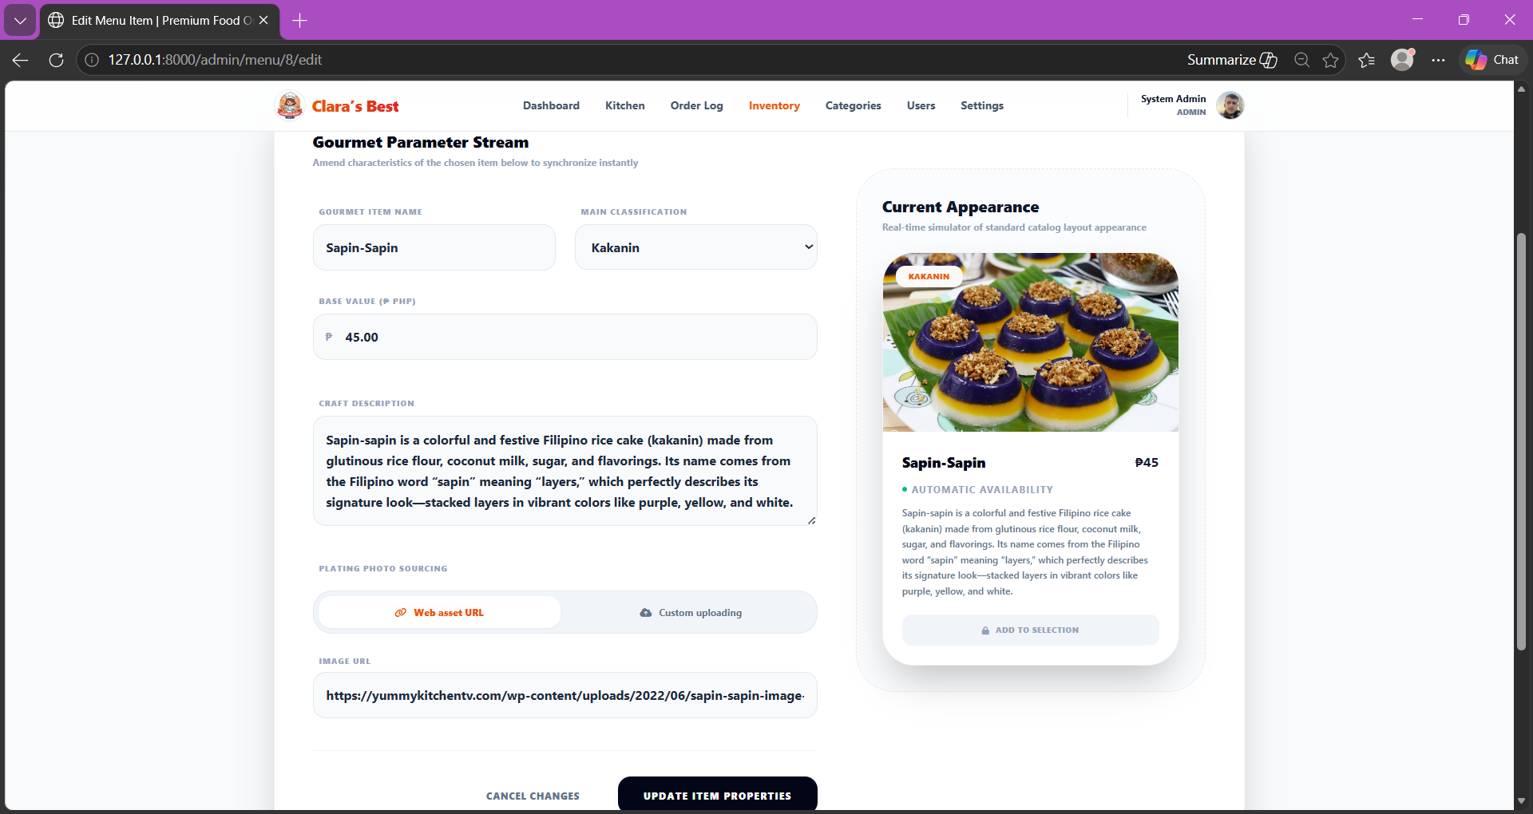
Figure 21: Admin Edit menu
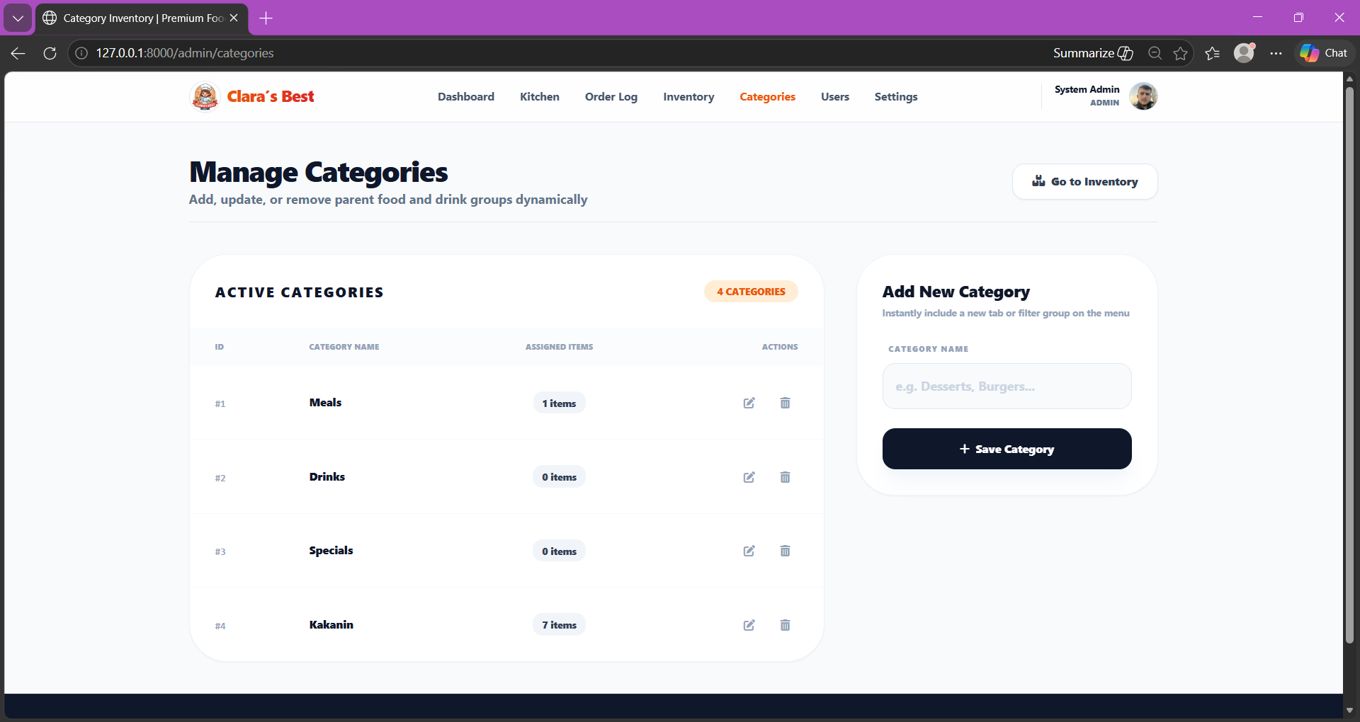
Figure 22: Admin Add Category
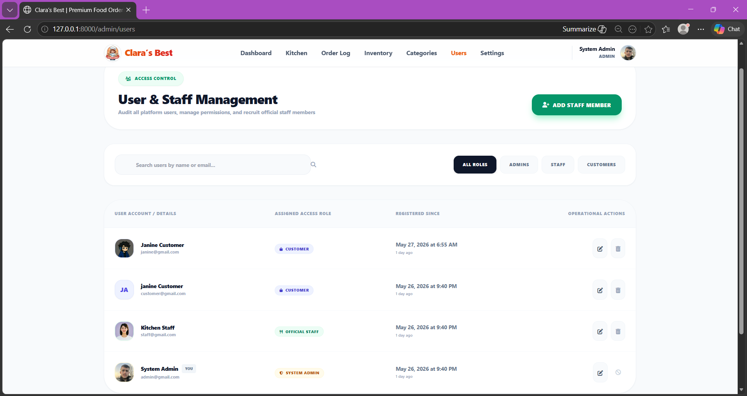
Figure 23: Admin Manage Users
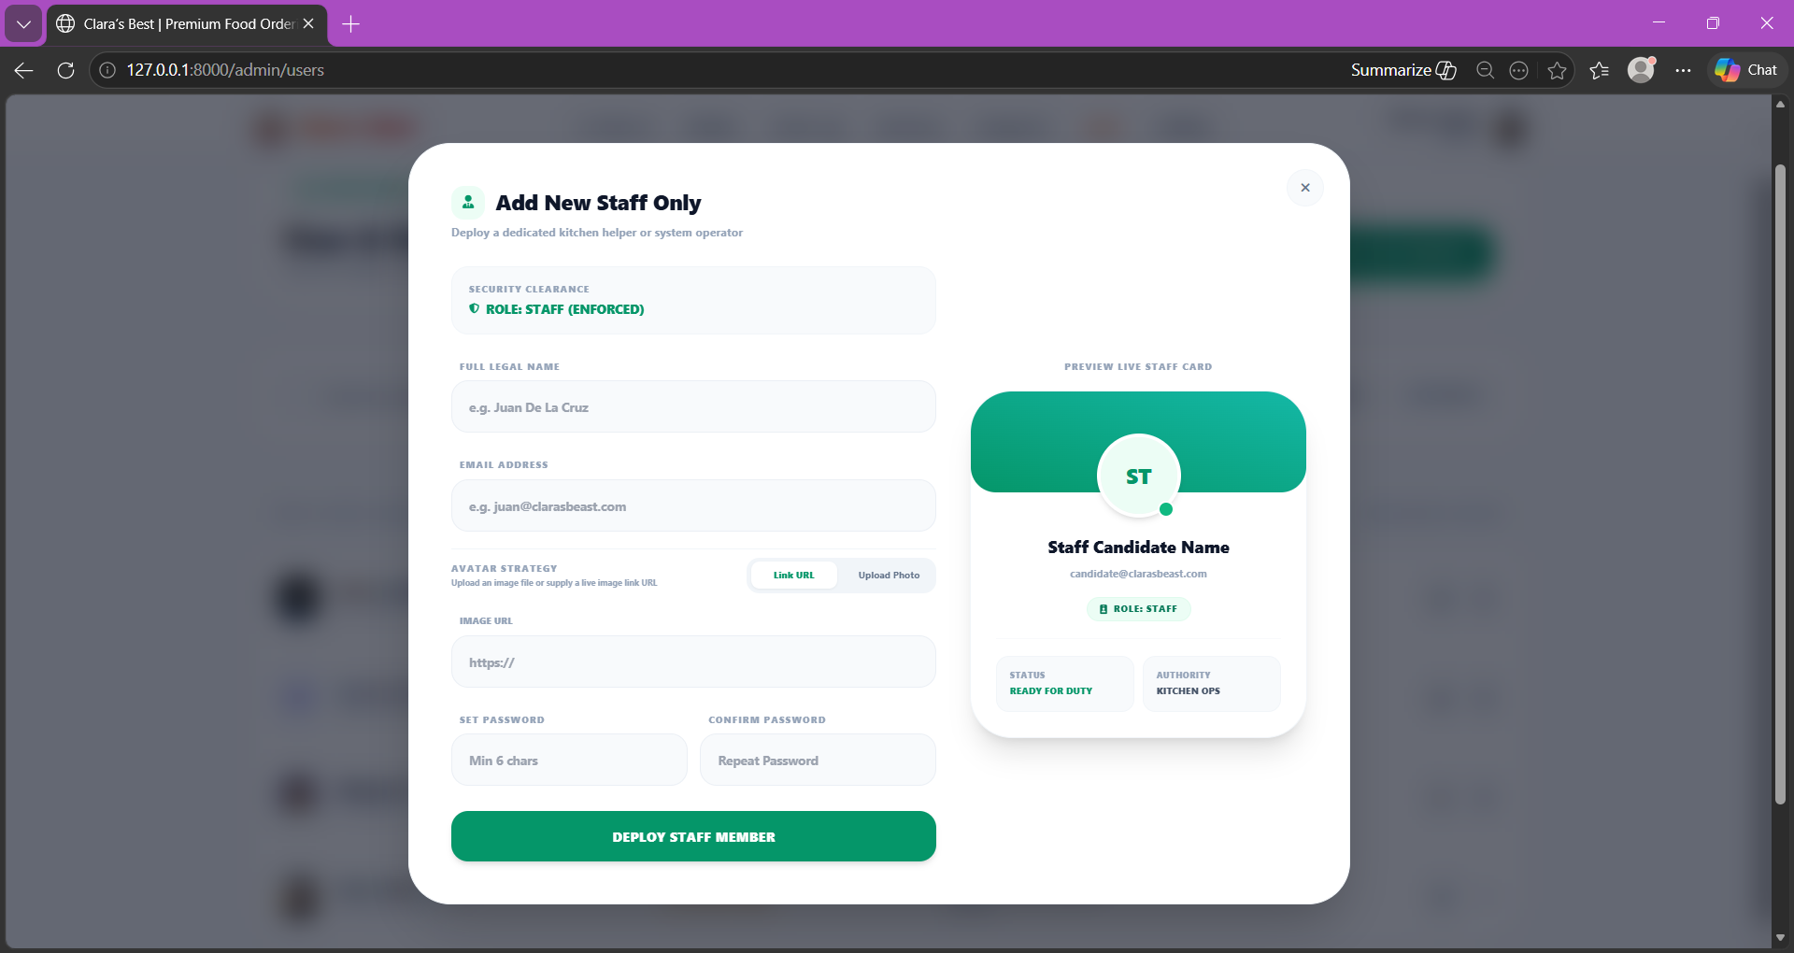
Figure 24: Admin Add Staff
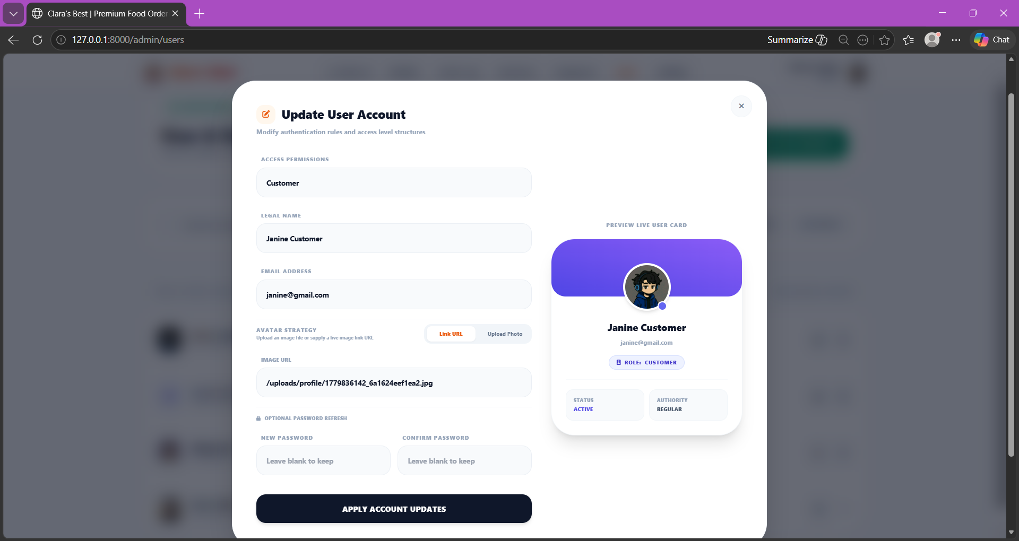
Figure 25: Admin Edit Users
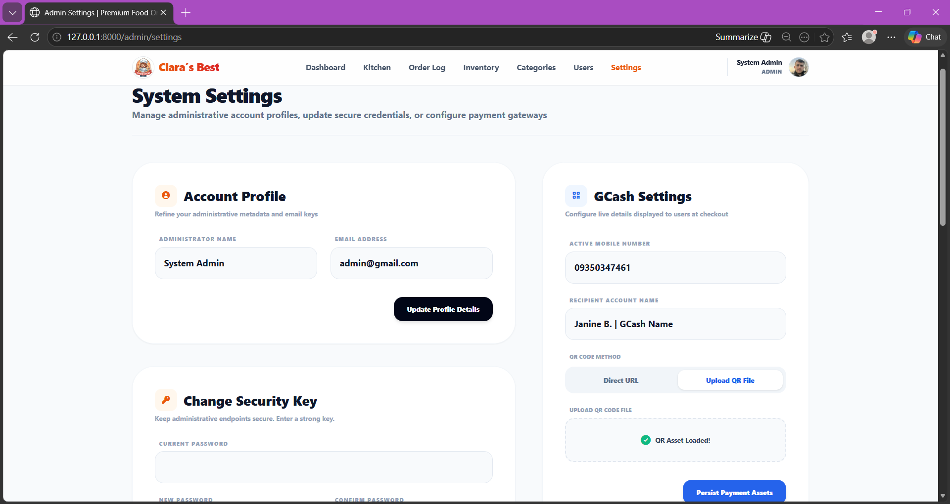
Figure 26: Admin Settings
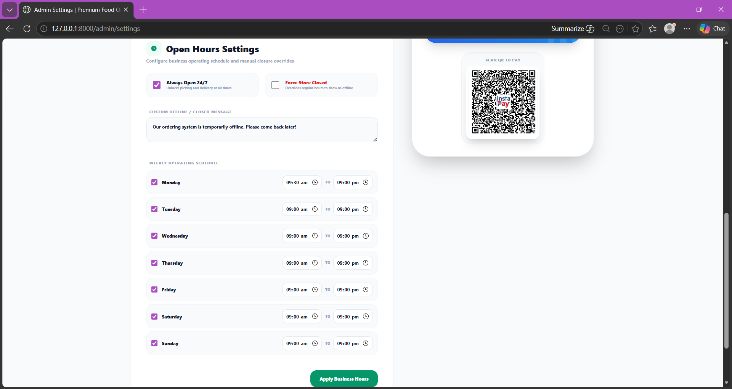
Figure 26: Admin Manage Open Hours

- Database Structure
Table Name | Key Fields / Columns | Primary / Foreign Keys | Description
users | name, email, password, role, profile_image, remember_token | id (PK) | Stores customer, staff, and administrator account information, authentication credentials, and role-based authorization data.
categories | name | id (PK) | Stores menu category classifications used to organize kakanin products within the system.
menu_items | name, description, price, category, image, availability_status, | id (PK) | Maintains product information including menu item details, pricing, descriptions, product images, and stock availability status.
orders | user_id, total_amount, order_type, status, payment_method, payment_status | id (PK), user_id (FK references users.id) | Serves as the primary transaction record for customer orders, payment details, and order status monitoring.
order_details | order_id, menu_item_id, quantity, subtotal, special_instructions. | id (PK), order_id (FK references orders.id) | Stores detailed order line items associated with customer transactions and selected menu products.
payments | order_id, payment_method, amount, payment_status, reference_number, proof_image | id (PK), order_id (FK references orders.id) | Stores payment information, uploaded GCash receipt images, and transaction verification records for customer orders.

- Implementation and Testing
Problem Encountered
- "SQLSTATE[42S22]: Column not found: 1054 Unknown column 'role' in 'field list'” occurred during database migration because the default Laravel users table did not initially include the customized role-based fields required by the system.
Solution Applied
- Modified the migration files and executed php artisan migrate to correctly rebuild the database schema and establish the required table relationships and custom columns.

- Conclusion
The Clara’s Best Ordering and Reservation System successfully transforms the business operations of the kakanin store from inefficient manual procedures into a centralized digital platform. Through the implementation of Laravel 12, MySQL, Tailwind CSS, and Alpine.js, the project demonstrates how modern web technologies can significantly improve order processing, reservation handling, payment verification, and sales reporting. The system minimizes administrative workload, improves transaction accuracy, and enhances customer convenience by providing an organized and reliable online ordering and reservation environment. Furthermore, the project strengthened the developers’ understanding of MVC architecture, relational database management, secure authentication systems, and responsive web application development.

- Recommendations
Future Enhancements
- Integration of SMS or email notification systems to automatically inform customers about order confirmations and status updates.
- Implementation of online payment gateway APIs for automated payment validation and transaction processing.
Operational Scaling
- Development of a dedicated mobile-responsive application version to improve accessibility and customer convenience across multiple devices.

